A Solution to the Three-bar-linkage Mechanism Problem Based on MATLAB

Yuchen Song Student No.201830360498

# Introduction

This project is aimed at solving a three-bar-linkage problem. In the problem, there are three bars connected head to tail one after another. The bar lengths and their initial positions are given. At then, link L1 started to rotate with an angular acceleration of 3 rad/s². We are then asked to find the angular velocities and angular accelerations of the three links and sketch the diagram of them with the help of our computers.

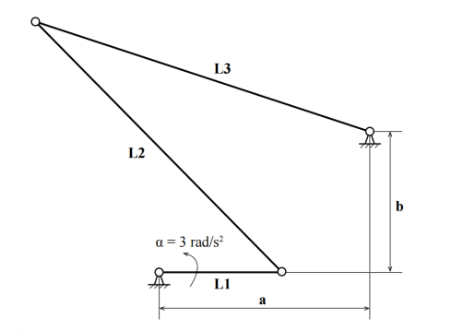

Figure 1 Diagram of the problem

# Solutions

## Link L1(solutions: $ω_{1}=(3t) rad/s^{2}, α_{1}=3 rad/s^{2}$)

To solve this problem, I came out with the idea of relative-motion analysis in chapter 16.

$$\begin{aligned}ω_{1}=α_{1}⋅t ⇒ ω_{1}=(3t) rad/s^{2}\#(A-1)\end{aligned}$$

$$\begin{aligned}V_{A}=V_{O}+ω_{1}×r_{A/O} =ω_{1}×r_{A/O} ⇒ V_{A}=V_{A}\left(t\right)\#\left(A-2\right)\end{aligned}$$

Then, to find $r_{A/O}$, I set up a coordinate system with the origin point at O and calculated the coordinates of A, $(0.35cosθ, 0.35sinθ)$, in which $θ=1/2⋅{ω_{1}}^{2}$.

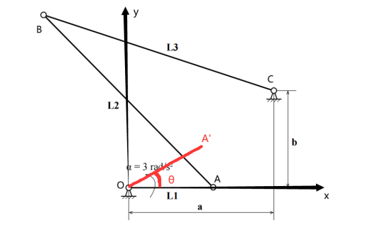

Figure 2 Set up a coordinate system

## Link L2

After I’ve gotten all the information of point A (coordinates, angular velocity, linear velocity, angular acceleration), it’s time to move on to solve the next point. Similarly, relative-motion analysis is applied.

$$\begin{aligned}V_{B}=V_{A}+ω_{2}×r_{B/A} ⇒ V_{B}=V_{B}\left(t,ω_{2}\right)\#\left(B-1\right)\end{aligned}$$

But before that, we have to calculate the coordinates of point B. I assumed the coordinates to be (x,y), and calculated the explicit expression with the equation AB=BC=1m.

$$\begin{aligned}\left|AB\right|=\left|BC\right|=1m ⇒ x=x\left(t\right), y=y\left(t\right)\#\left(B-2\right)\end{aligned}$$

Here we need to pay attention to the solutions. Since it is binary quadratic equations, it can provide two roots. Explicit explanation is that we used the distance relation to find the coordinates of B, there exists two of them, and what we need to do is to choose the one with smaller x and larger y.

$$\begin{aligned}x=min\left(solutions\left(x\right)\right), y=max\left(solutions\left(y\right)\right)\#\left(B-3\right)\end{aligned}$$

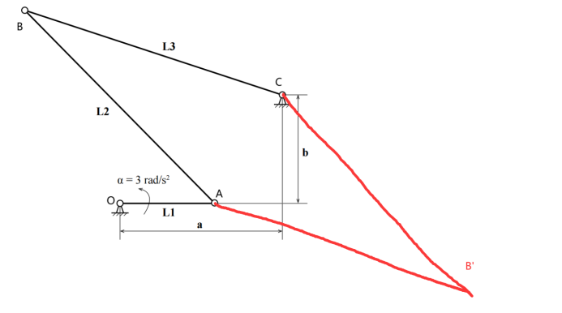

Figure 3 Two solutions of B(x,y)

## Link L3

For link L3, I tried to solve it in an opposite direction. (i.e., try to express the attributes of point B with symbols of point C).

$$\begin{aligned}V_{B}=V_{C}+ω_{3}×r_{B/C}= ω_{3}×r_{B/C} ⇒ V_{B}=V_{B}\left(t,ω_{3}\right)\#\left(C-1\right)\end{aligned}$$

Finally, I equal two expressions of $V_{B}$ and solved these sets of equations with the help of MATLAB:

$$\begin{aligned}\left\{\begin{aligned}V_{Bx}\left(t,ω_{2}\right)=V_{Bx}\left(t,ω_{3}\right) \\ V_{By}\left(t,ω_{2}\right)=V_{By}\left(t,ω_{3}\right)\end{aligned}\right. ⇒ \left\{\begin{aligned}ω_{2}=ω_{2}\left(t\right) \\ ω_{3}=ω_{3}\left(t\right)\end{aligned}\right.\#(C-2)\end{aligned}$$

As for the angular acceleration, a simple differentiating procedure is used.

$$\begin{aligned}\left\{\begin{aligned}α_{1}=\frac{d\left(ω_{1}\right)}{dt}=α_{1}\left(t\right) \\ α_{2}=\frac{d\left(ω_{2}\right)}{dt}=α_{2}\left(t\right) \\ α_{3}=\frac{d\left(ω_{3}\right)}{dt}=α_{3}\left(t\right)\end{aligned}\right.\#(C-3)\end{aligned}$$

# Results

I draw the diagrams of the angular velocities and angular accelerations of the three bars separately, which are shown below.

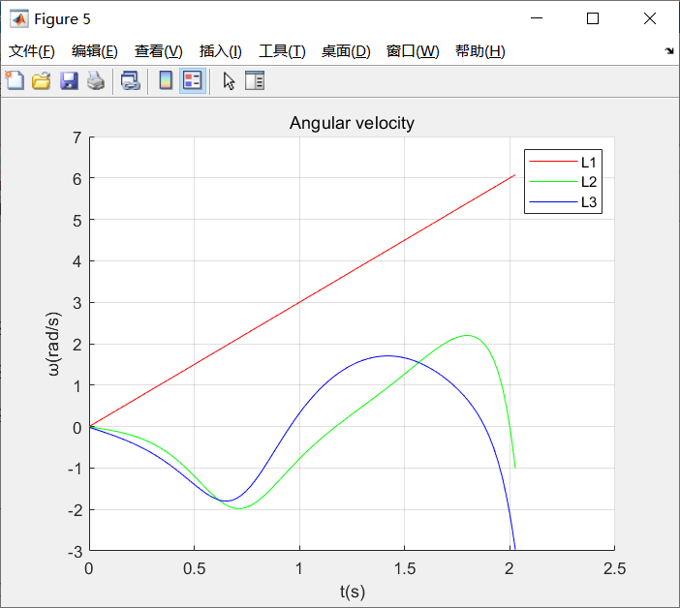 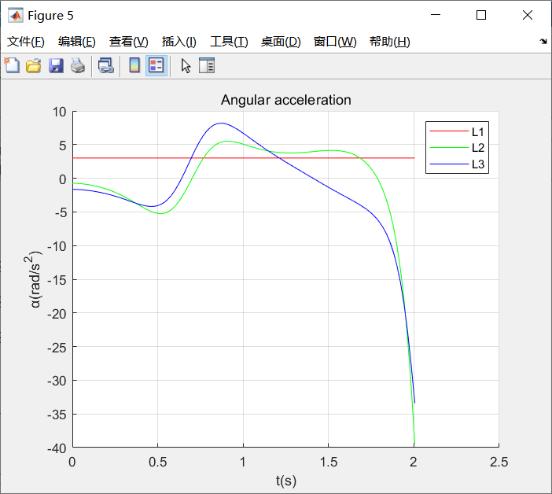

Figure 4 Angular velocity and angular acceleration of three bars

# Conclusion

In this project, I solved the problem of a three-bar-linkage mechanism based on the relative velocity and relative angular velocity equations. I also set up a coordinate system to find the relative displacement between the three points. By applying relative-motion analysis, this kind of bar linkage problem can be solved easily.

# Appendix

## A. Code

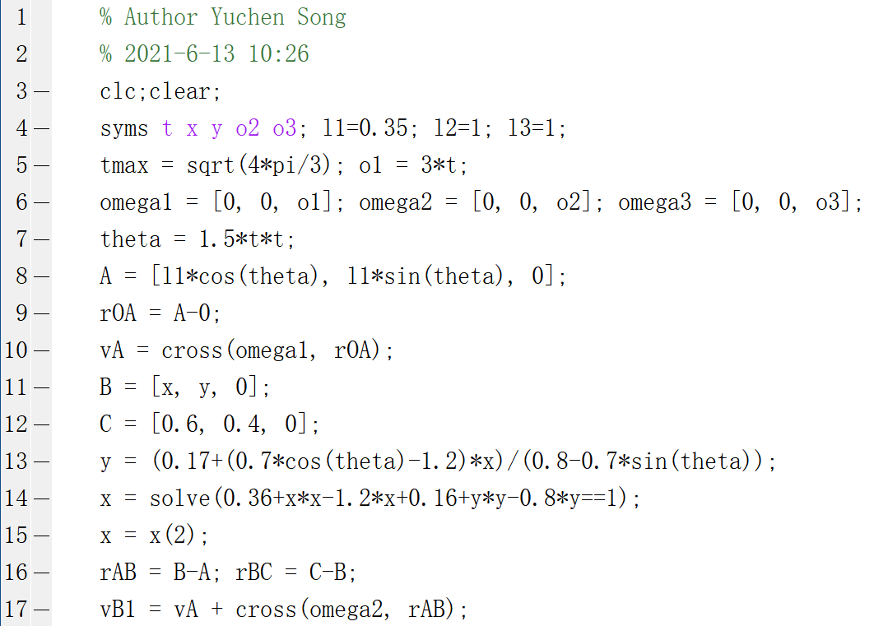

## B. Variables

